­­



# Inaugural Minnesota Holocaust Educators Network Seminar

# Minneapolis-Saint Paul, Minnesota

### July 30 - August 5, 2017

## **The Holocaust**

## **and**

## **The Meaning of Place**

A weeklong seminar for K-12 educators and administrators to explore place-based, inquiry lessons around the Holocaust, the Dakota exile and other social justice topics

**Seminar Location: University of Minnesota, Twin Cities Campus**

Seminar Co-Leaders:

Maureen Mahoney, 7-8 English Language Arts Teacher, American Indian Magnet School

Merry Meltz, K-8 Literacy & Content Integration Coach, American Indian Magnet School

Questions? Email:

Maureen Mahoney, maureenm1963@gmail.com

Merry Meltz, merrymeltz@gmail.com

**For More Information and to Register, Go To:**

**https://www.thememoriallibrary.org/satellite-program/st-paul/**

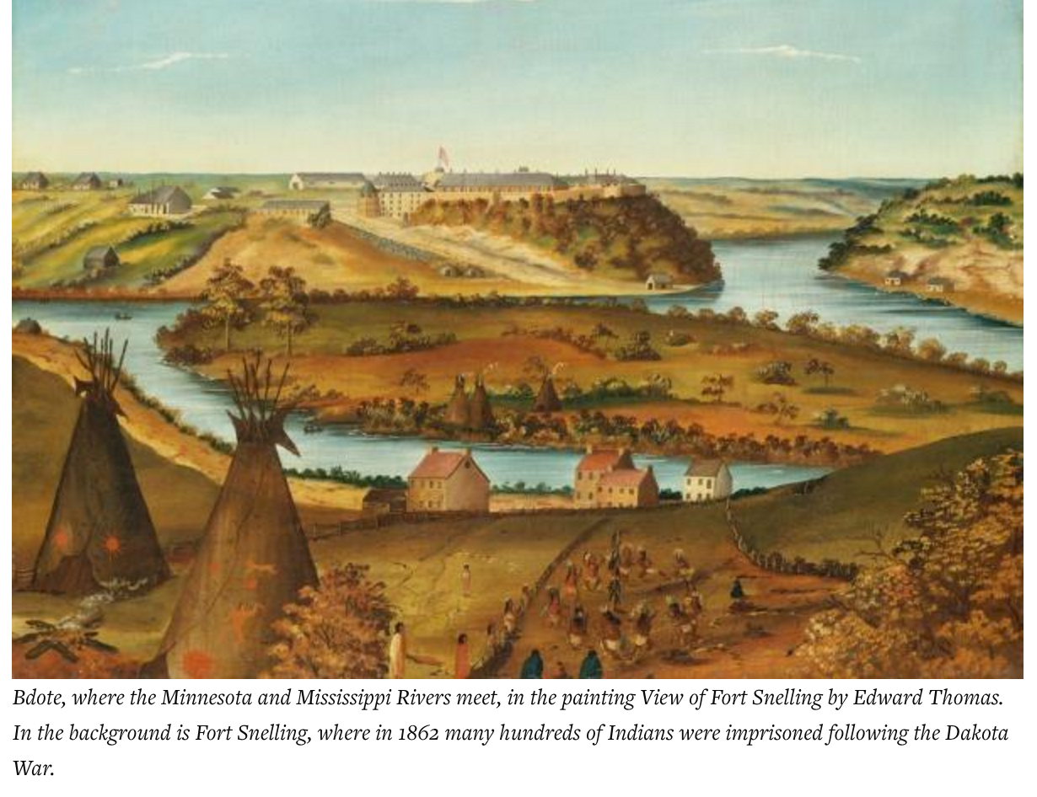

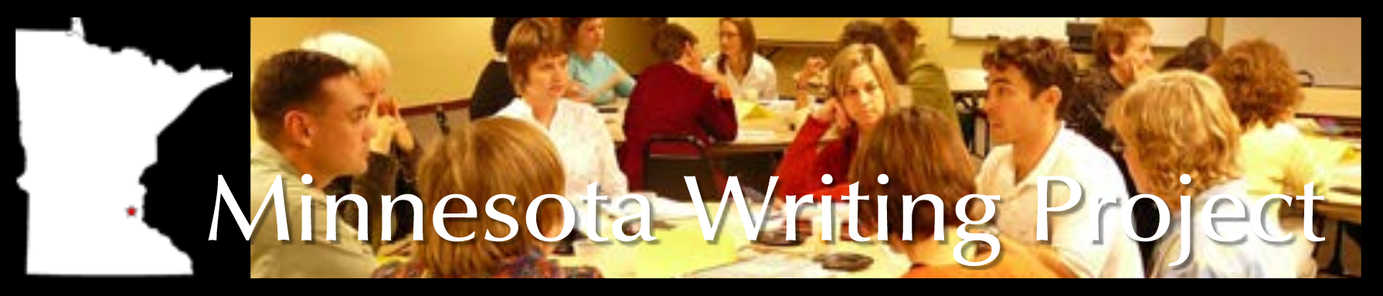

Participants will:

* Complete pre-seminar readings and engage in on-line discussions
* Attend scheduled sessions
* Complete reflective writing assignments
* Create an action plan
* Join the Holocaust Educator Network at completion of seminar

Participants are eligible for:

* Classroom grants up to $1000
* Professional development hours
* U of M credit options may be pursued individually

Participants receive:

* Low cost housing on U of M/Twin Cities campus (if needed)
* Free copies of selected Holocaust & Dakota related books
* Echoes & Reflection curriculum
* Most meals
* $100 stipend

**Seminar Highlights will include:**

Holocaust Survivor testimonies | Dakota Descendant testimonies | Field experiences at Mount Zion Temple, Saint Paul and Dakota Historic sites from Mendota to Mankato | Model lessons using primary source documents | Inquiry and place-based learning | AND many others...