­­



# Holocaust Educators Network Summer Seminar on

# Holocaust Education & Social Justice

# at Cal State San Marcos



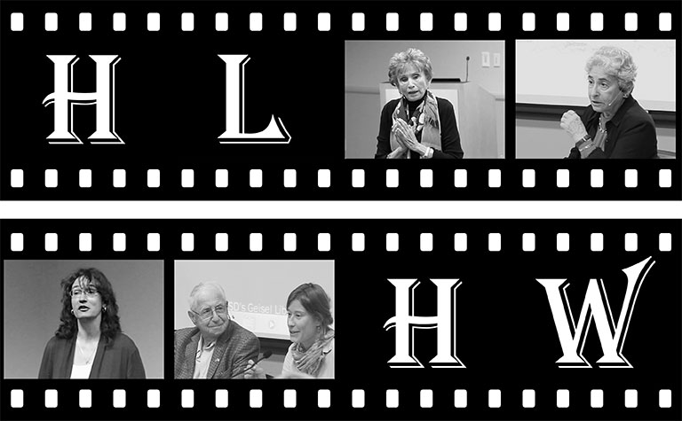

**Speakers and events will include:**

Testimony from a Holocaust Survivor

Speakers from Facing History and Ourselves, Echoes and Reflections and USC Shoah Foundation

Visit to Museum of Tolerance

Visit to Museum of Man

Storytelling workshop

Shabbat Service, Dinner, Klezmer Performance & more

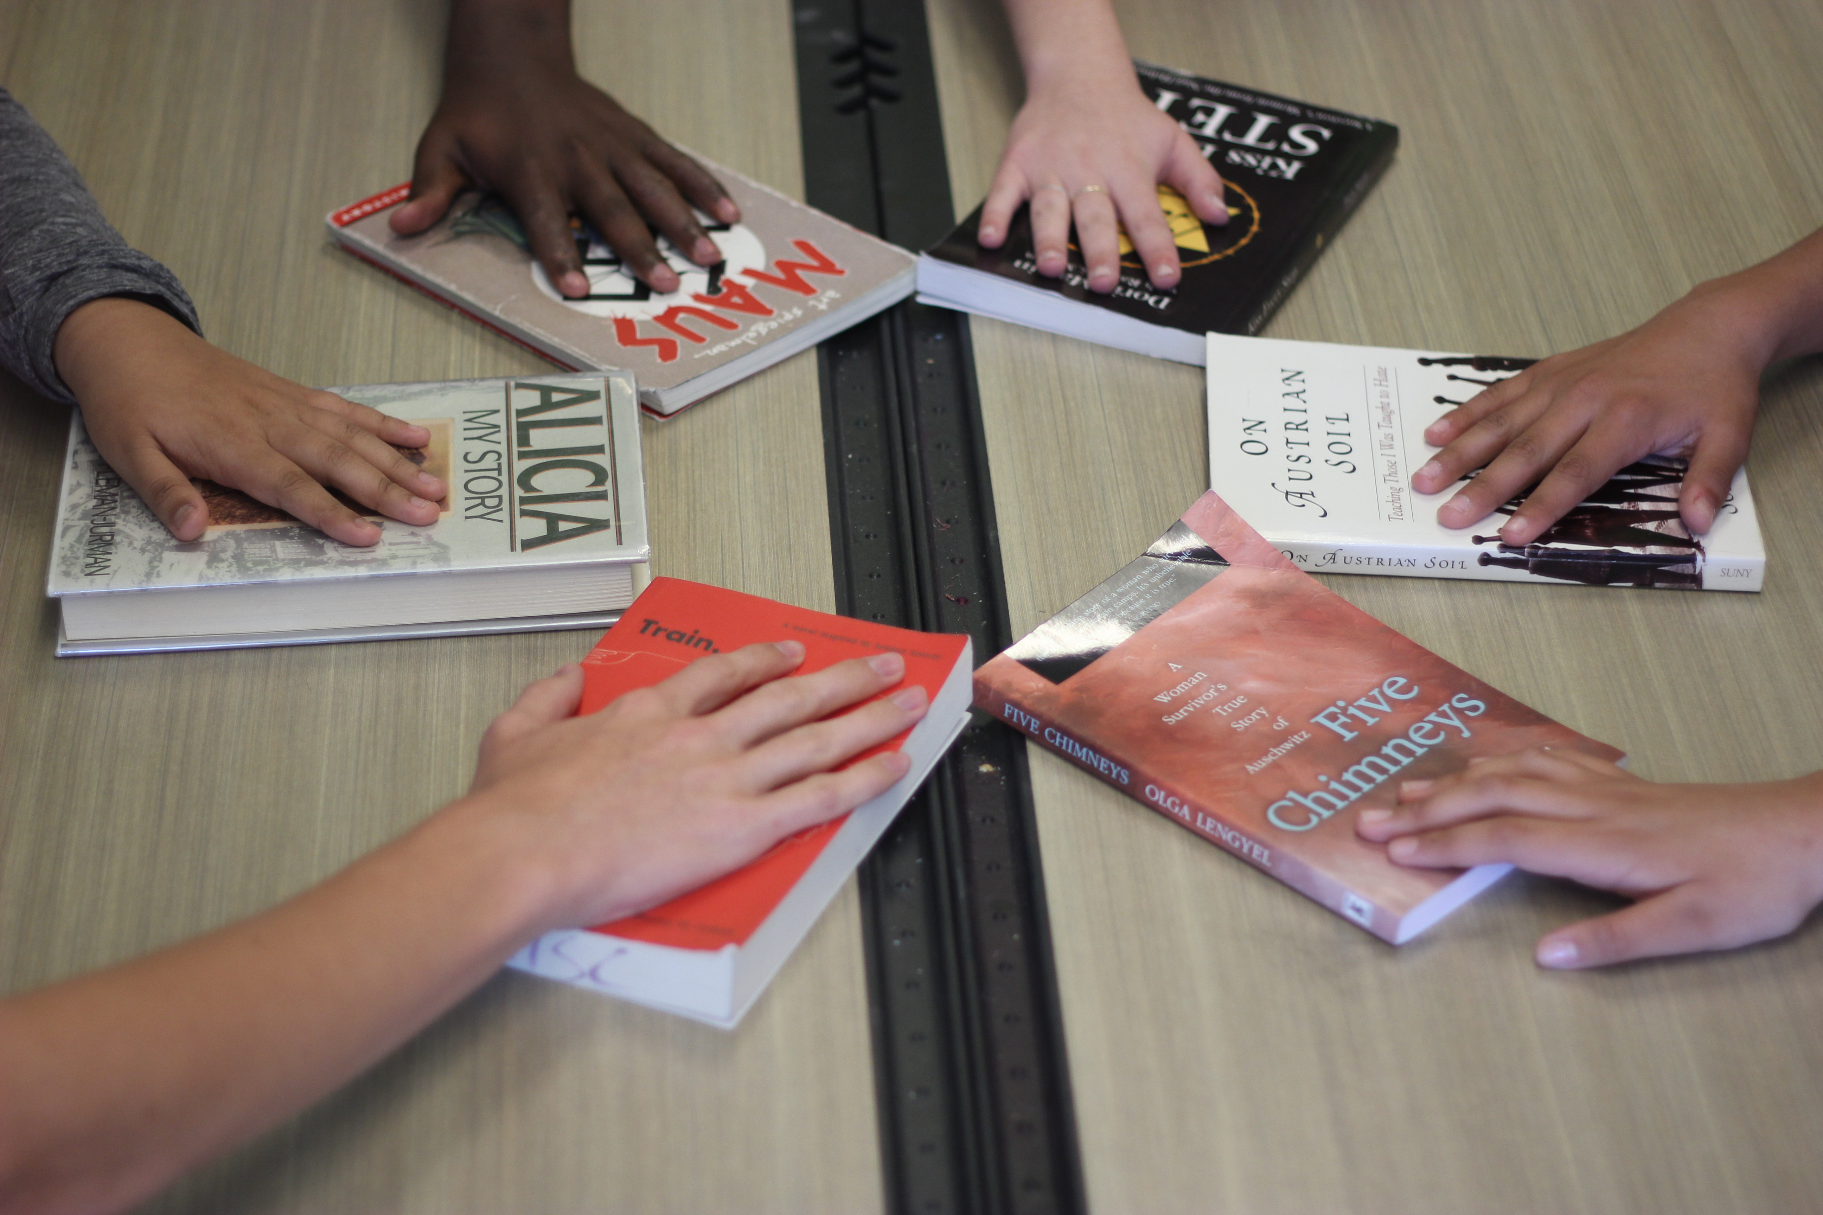

### July 23-July 29, 2017

### The Holocaust and Cultural Identity in the Classroom

A thematic seminar that will interweave content related to both the Holocaust and present-day experiences of intolerance and persecution. The seminar is inquiry-based, inviting teachers to acknowledge and incorporate the culture of their students into their curriculum and the broader classroom experience. The program takes a writing-based approach to Holocaust and social justice education.

Led by Michelle Sadrena Clark and Jennifer Howard

High Tech High North County Educators and

San Marcos Writing Project Fellows

Participants can receive

* Three units of graduate credit for $80 a unit

Participants receive

* Free admission to all field trips and speakers
* All workshop materials
* Membership in the Holocaust Educators Network
* Parking

To apply, fill out application at:

<https://www.thememoriallibrary.org/satellite-program/san-diego/>

Apply early! We will cap at 20.

For more information email: [lstowell@csusm.edu](mailto:lstowell@csusm.edu)