­­



**Inaugural Wisconsin Holocaust Educators Network Seminar**

**Milwaukee, Wisconsin**

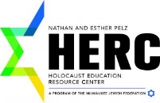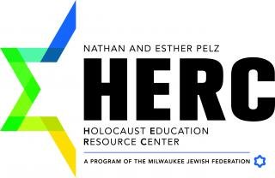

**Apply Now!**

[**https://www.thememoriallibrary.org/wisconsin-application/**](https://www.thememoriallibrary.org/wisconsin-application/)

**For More Information:**

**Scott Lone,** **scottlone@gmail.com**

**Lori Menning,** **holalori2010@gmail.com**

Participants are expected to:

* Complete pre-seminar readings and engage in on-line discussions
* Attend scheduled sessions
* Fully participate in planned activities
* Complete reflective writing assignments
* Create an action plan to take back to your school

**Featured Speakers**

* Dr. Shay Pilnik: History of the Holocaust

* Nathan Taffel: Child Survivor of the Holocaust

* Elaine Culbertson: Importance of Artifacts in Holocaust Education

* Jill Rembrandt: Echoes & Reflections Curriculum

* Hannah Rosenthal, Former US Envoy: Anti-Semitism Today

### July 31 – August 5, 2017

# **A MULTI-GENERATIONAL APPROACH TO HOLOCAUST AND SOCIAL JUSTICE EDUCATION**

A weeklong seminar for teachers to learn and work together to create pedagogically sound lessons centered around the Holocaust and other social justice topics

**Led by:**

**Scott Lone, West Bend High Schools**

**&**

**Lori Menning, New London High School**

Participants receive free:

* Copies of select Holocaust related books
* Most meals
* Echoes and Reflections curriculum
* Trip to the Illinois Holocaust Memorial Museum & a local synagogue

Participants are eligible for:

* 2 or 3 graduate credits through UW-Oshkosh (additional cost and outside work)
* Classroom grants for up to $1000
* Professional development hours